微机原理与接口技术上机实验
实验七
利用主程序与子程序传递参数的四种方法实现三个两字节数相加，编程并调试
- 利用寄存器进行参数传递：
DATA SEGMENT
ARRAY DB 12H,34H,56H
COUNT DB $-ARRAY
SUM DW 0
DATA ENDS
CODE SEGMENT
ASSUME CS:CODE,DS:DATA
START: MOV AX,DATA
MOV DS,AX
LEA SI,ARRAY
MOV CL,[COUNT]
CALL SUM1
MOV SUM,AX
MOV AH,4CH
INT 21H
SUM1 PROC NEAR
CMP CX,0
JZ EXIT
MOV AX,0
AGAIN: ADD AL,[SI]
ADC AH,0
INC SI
LOOP AGAIN
EXIT: RET
SUM1 ENDP
CODE ENDS
END START
调试截图：

寄存器CX,SI将参数传入函数内。
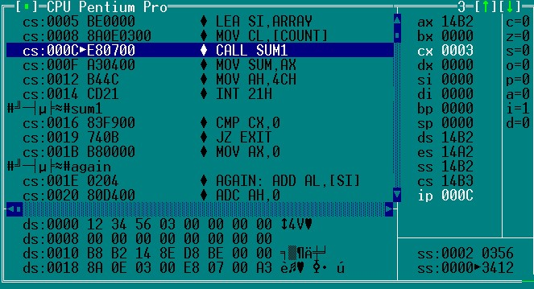
寄存器AX将结果传递出函数。
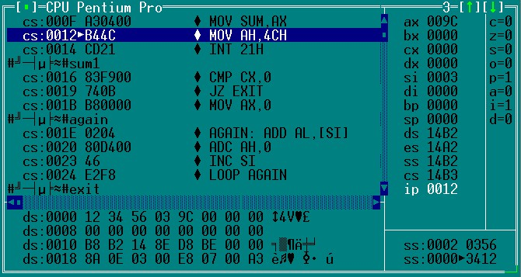
- 利用存储单元进行参数传递：
DATA SEGMENT
ARRAY DB 12H,34H,56H
COUNT DB $-ARRAY
SUM DW 0
DATA ENDS
CODE SEGMENT
ASSUME CS:CODE,DS:DATA
START: MOV AX,DATA
MOV DS,AX
CALL SUM1

MOV AH,4CH
INT 21H
SUM1 PROC NEAR
MOV CL,[COUNT]
CMP [COUNT],0
JZ EXIT
MOV AX,0
MOV SI,0
AGAIN: ADD AL,[ARRAY+SI]
ADC AH,0
INC SI
LOOP AGAIN
MOV SUM,AX
EXIT: RET
SUM1 ENDP
CODE ENDS
END START
调试截图：
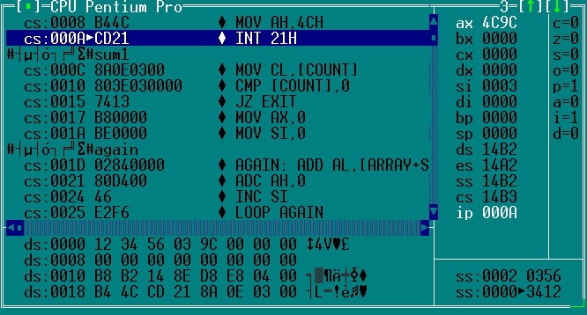
- 利用堆栈段进行参数传递：
STACKS SEGMENT STACK PARA STACK 'stack'

DW 20 DUP(?)
STACKS ENDS
DATAS SEGMENT ;数据段
DATA1 DB 12H,34H,56H
COUNT DB $-DATA1
SUM DW 0
DATAS ENDS
CODE SEGMENT
ASSUME CS:CODE,DS:DATAS,SS:STACKS

START: MOV AX,DATAS
MOV DS,AX
MOV AX,STACKS
MOV SS,AX

LEA BX,DATA1
PUSH BX
LEA BX,COUNT
PUSH BX
LEA BX,SUM
PUSH BX
CALL SUM1
MOV AH,4CH
INT 21H
SUM1 PROC NEAR
PUSH AX
PUSH BX
PUSH CX
PUSH BP
MOV BP,SP
MOV BX,[BP+12]
MOV CX,[BX]
MOV BX,[BP+10]
MOV SI,[BP+14]
MOV AX,0
CMP CX,0
JZ EXIT
MOV AX,0
AGAIN: ADD AL,[SI]
ADC AH,0
ADD SI,1
LOOP AGAIN
MOV [BX],AX
POP BP
POP CX
POP BX
POP AX
EXIT: RET
SUM1 ENDP
CODE ENDS
END START
调试截图：
将参数存放的存储器的地址放在堆栈段中传入函数：
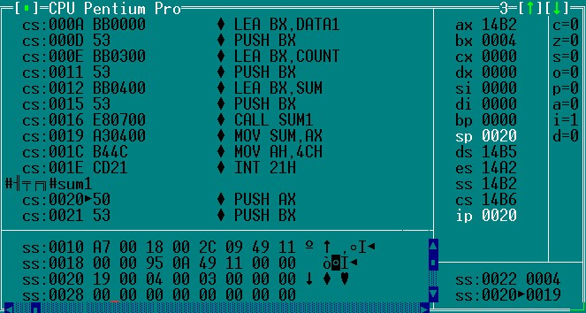
将结果传递到堆栈段中存储的地址所对应的存储空间
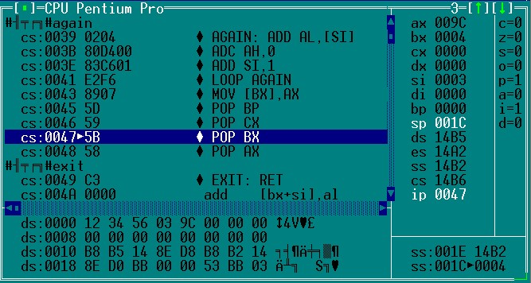
- 利用地址表进行参数传递：
STACKS SEGMENT STACK PARA STACK 'stack'

DW 20 DUP(?)
STACKS ENDS
DATAS SEGMENT ;数据段
DATA1 DB 12H,34H,56H
COUNT DW $-DATA1
SUM DW 0
LIST DW 3 DUP(0)
DATAS ENDS
CODE SEGMENT
ASSUME CS:CODE,DS:DATAS,SS:STACKS

START: MOV AX,DATAS
MOV DS,AX
MOV AX,STACKS
MOV SS,AX

MOV LIST,OFFSET DATA1
MOV LIST+2,OFFSET COUNT
MOV LIST+4,OFFSET SUM
LEA BX,LIST

CALL SUM1
MOV SUM,AX
MOV AH,4CH
INT 21H
SUM1 PROC NEAR
PUSH AX
PUSH BX
PUSH CX
PUSH SI

MOV SI,[BX]
MOV CX,[BX+2]
MOV DI,[BX+4]
MOV AX,0

AGAIN: ADD AL,[SI]
ADC AH,0
ADD SI,1
LOOP AGAIN
MOV [DI],AX

POP SI
POP CX
POP BX
POP AX
EXIT: RET
SUM1 ENDP
CODE ENDS
END START
调试截图：
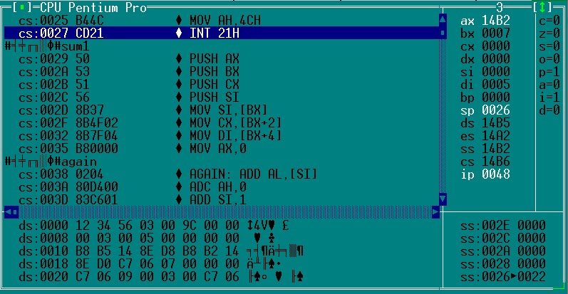
结果
将参数所存的存储器的偏移地址依序存入地址表list中。并将list首地址赋给BX

